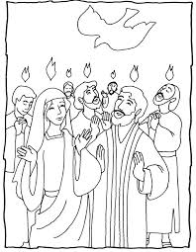

Acts 2:1-4
When the day of Pentecost had come, they were all together in one place. And suddenly there came from heaven a noise like a violent rushing wind, and it filled the whole house where they were sitting. And there appeared to them tongues as of fire distributing themselves, and they rested on each one of them. And they were all filled with the Holy Spirit and began to speak with other tongues, as the Spirit was giving them utterance.

